**CB[1] – Enrichment – ANCOVA**

Part I – Individual Quiz (Before Class)

Part II – Group Quiz (During Class)

1. What is ANCOVA (2 pts)?

Analysis of Covariance

1. What are the advantages for ANCOVA (3 pts)?

Can reduce bias, by adjusting for differences between treatment groups.

Can reduce residual sum of squares by fitting and removing systematic variability

1. When is ANCOVA not suitable (2 pts)?

If the relationship between response and covariate is not linear

If the relationship is linear, but lines fitted to the groups of points have unequal slopes.

If adjusting for group differences violates common sense.

1. When is it better to do blocking than ANCOVA (2 pts)?

If covariate values are known before you assign treatments, using the covariate to define blocks may be better than ANCOVA.

**End of Part I**

1. Were you in class on time (2 pts)?

YES

1. Using the handwash data, you want to determine if the type of hand sanitizer reduces the amount of CFU (Bad type of bacteria). Use CFU.After as the response, CFU.Before as the covariate and Cleanser as the factor. Please do the following three items:
   1. Check if there is no interaction between the covariate (3 pts)

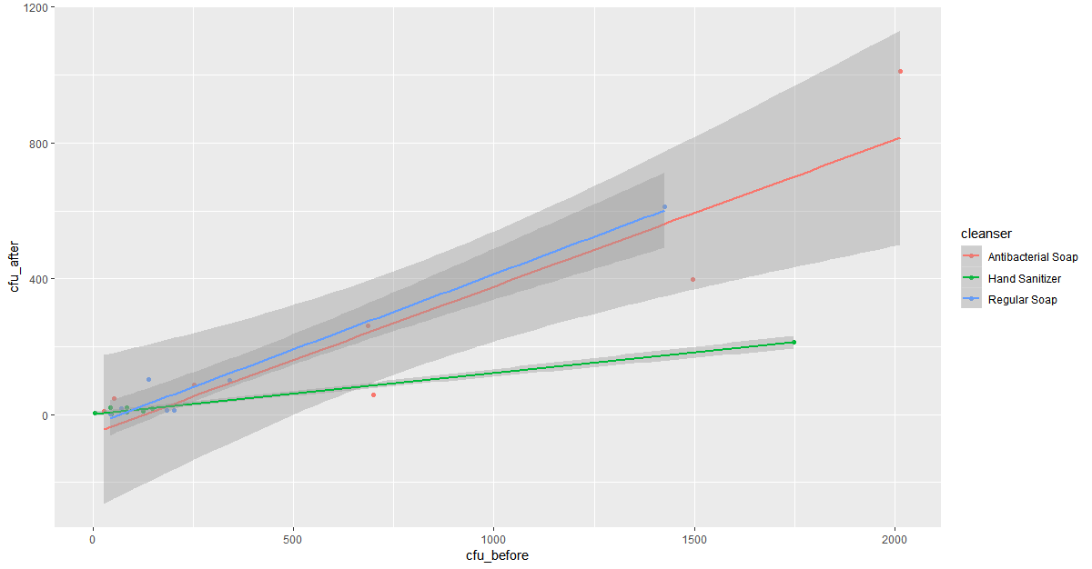

* 1. Run the ANCOVA model (show the table) and summarize the results (3 pts)

1. Anova Table (Type III tests)
2. Response: cfu_after
3. Sum Sq Df F value Pr(>F)
4. (Intercept) 9534 1 1.1438 0.300722
5. cfu_before 707355 1 84.8585 8.5e-08 ***
6. cleanser 7498 2 0.4498 0.645602
7. cfu_before:cleanser 161501 2 9.6873 0.001752 **
8. Residuals 133371 16
9. ---
10. Signif. codes: 0 ‘***’ 0.001 ‘**’ 0.01 ‘*’ 0.05 ‘.’ 0.1 ‘ ’ 1

There is an interaction between the before and the cleanser.

Anova Table (Type III tests)

Response: cfu_after

Sum Sq Df F value Pr(>F)

(Intercept) 921 1 0.0562 0.8152

cfu_before 792305 1 48.3649 1.695e-06 ***

cleanser 26019 2 0.7941 0.4672

Residuals 294873 18

---

Signif. codes: 0 ‘***’ 0.001 ‘**’ 0.01 ‘*’ 0.05 ‘.’ 0.1 ‘ ’ 1

There is still a significance without the interaction to the cfu_before term.

* 1. Do a qqplot and histogram of the residuals to see if we can assume normality (3 pts)

